MORDERN JAVASCRIPT

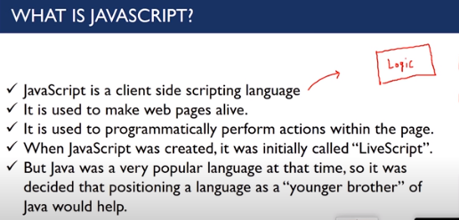

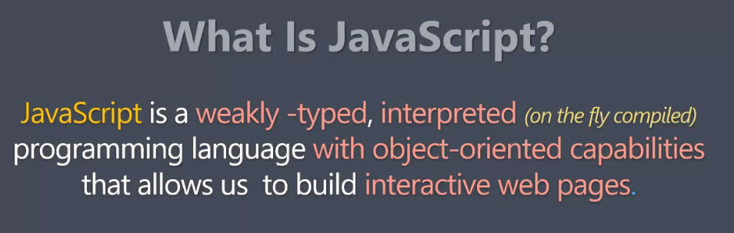

**Weekly typed**- no boundation on data type.

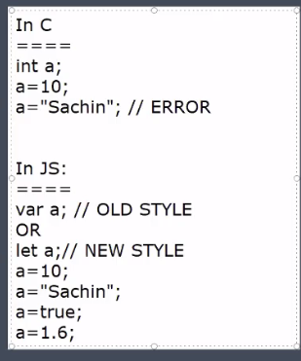

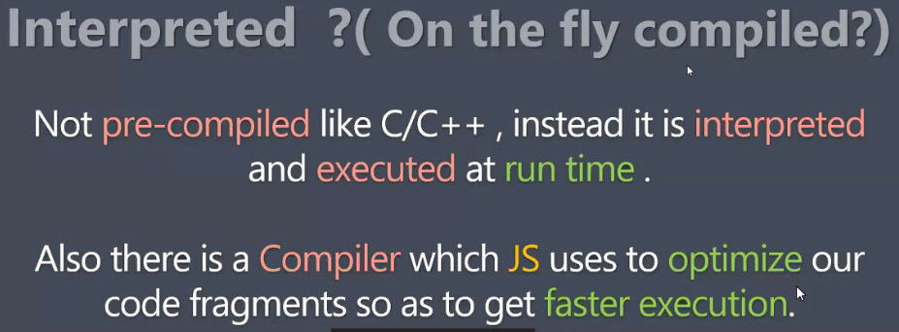

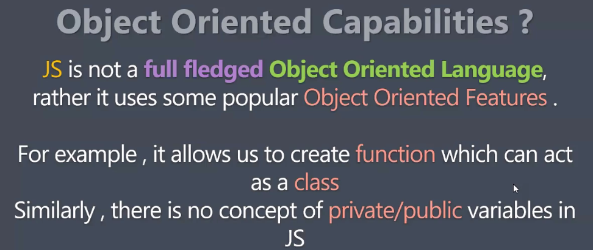

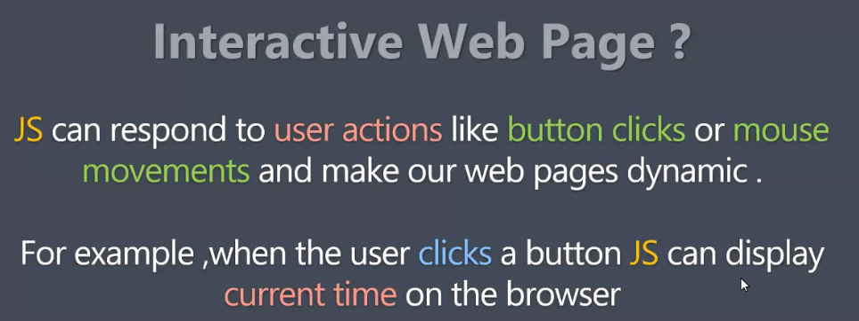

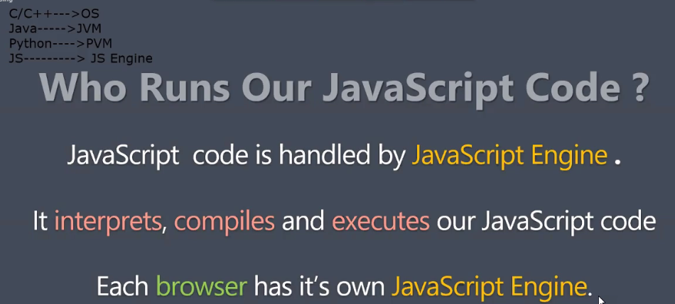

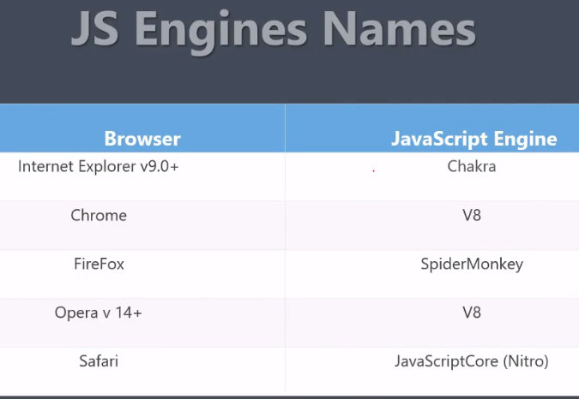

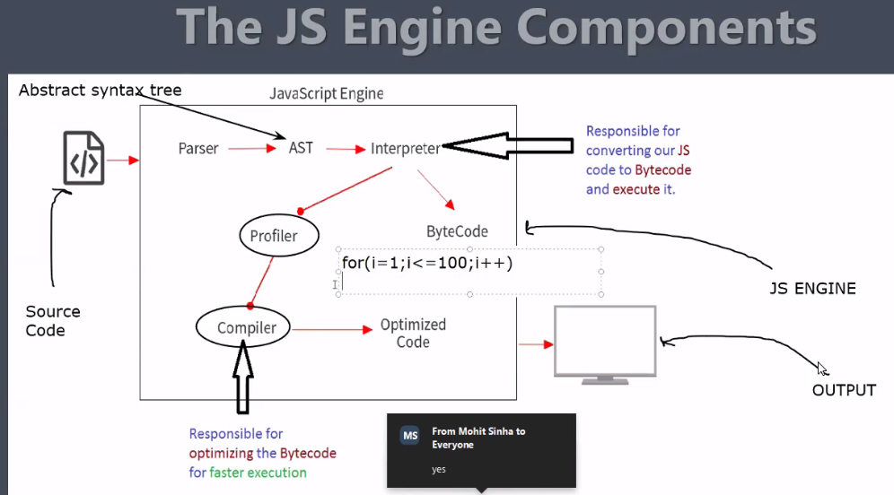

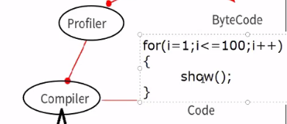

This code will run by 100 times , 100 times it will call function.

So compiler will optimise this code by—

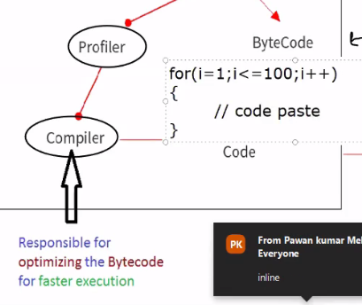

In V8

Compiler name is - turbo fan ,Interpreter name is – Ignition

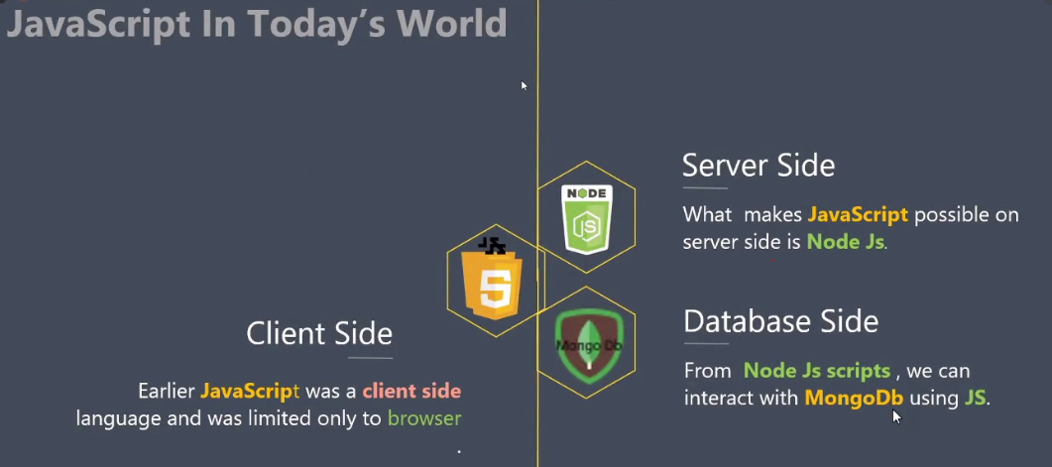

All of three are called – Host environment

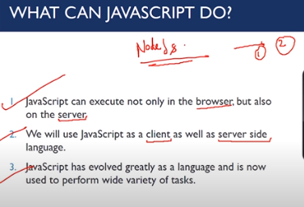

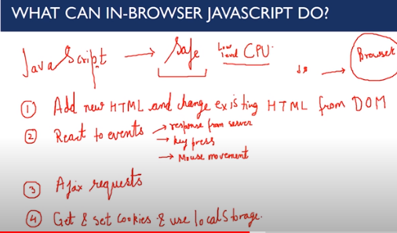

++ adding pts—

User Interaction, Form validation, image scroll/roll/swap

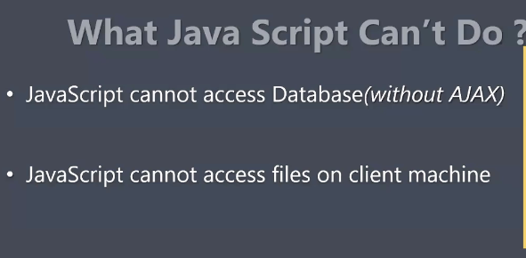

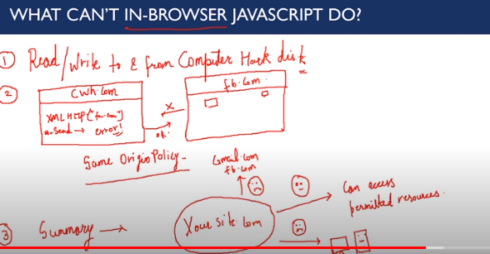

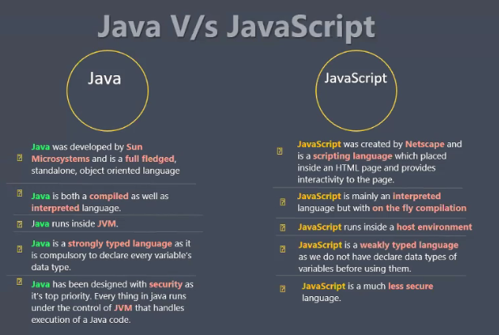

Diff b/w programming lang and scripting lang

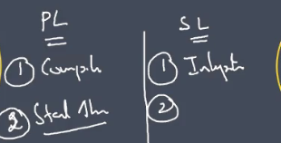

Scripting me compiler nhi hota , liken JS me to h ?

Yes but compiler ka kaam rehta h byte code/machine understandable form me convert krna. And JS me byte code to interpreter bnata h, compiler sirf optimization krta h.

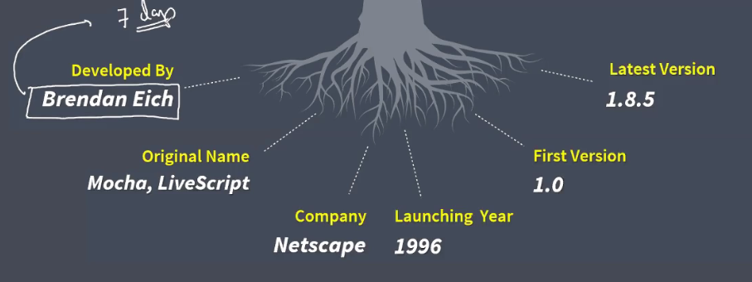

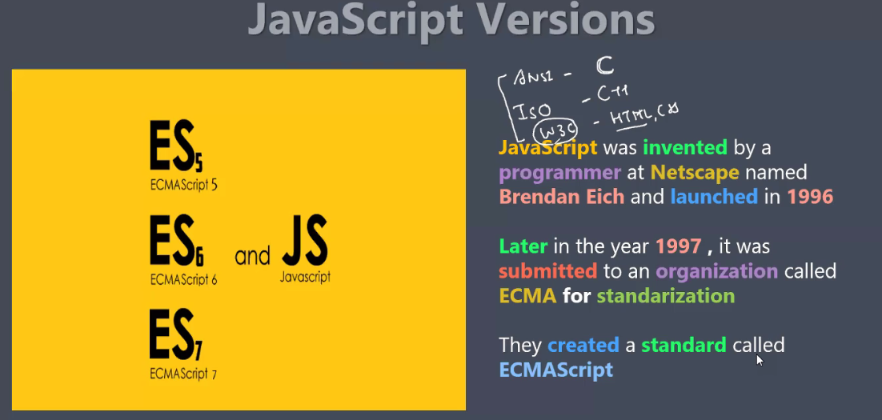

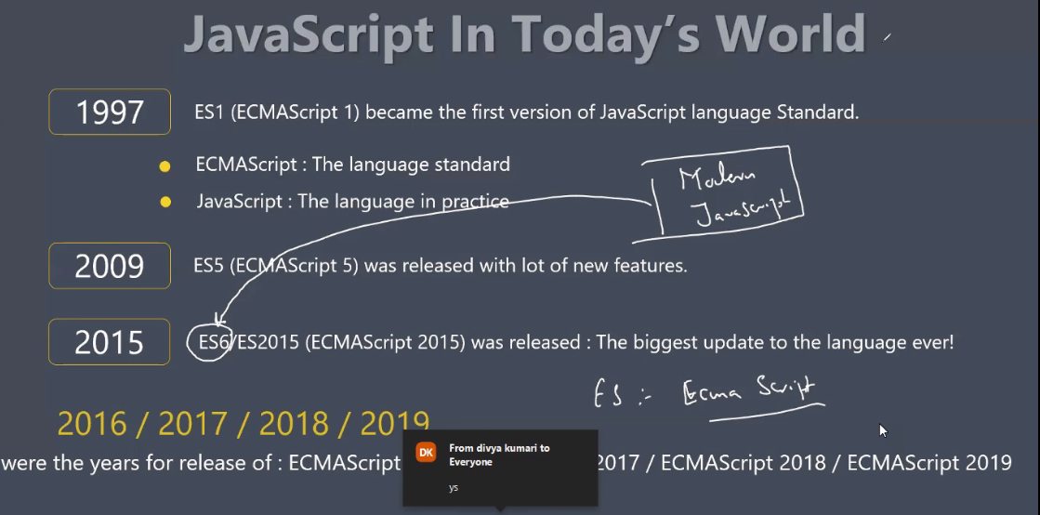

ES6- es6 ne resposiblity li ki , aapka code every browser pe same work krega , V8 ho ya koi dusra engine . esliye es6 etna popular ho gya.

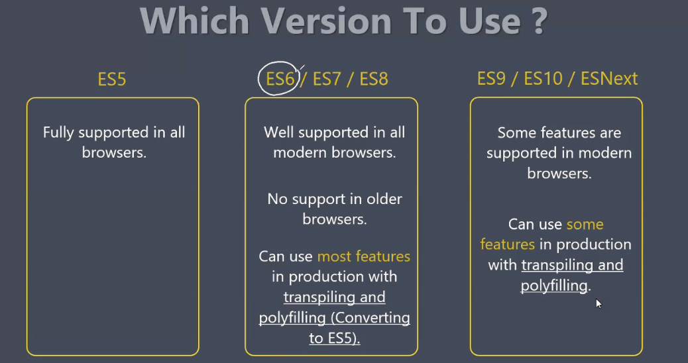

If anyone has not updated browser , and it support only ES5 then ?

ES6 has capability to convert ES6 to ES5 using tranpiler called as babel.

Angular and React eska bhrpur use krte h.

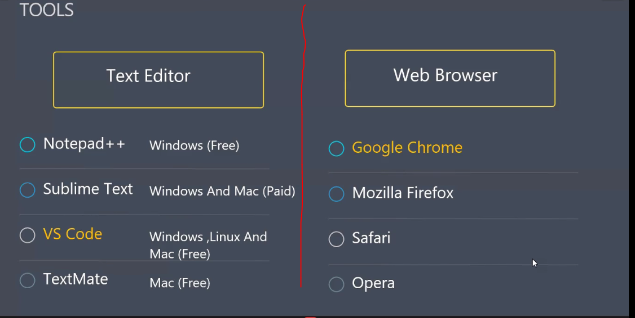

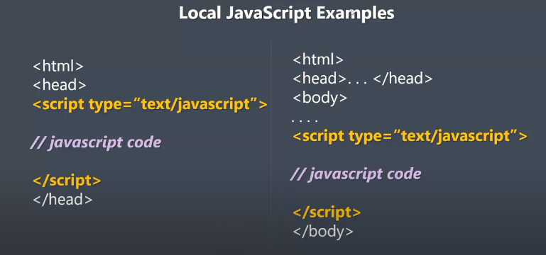

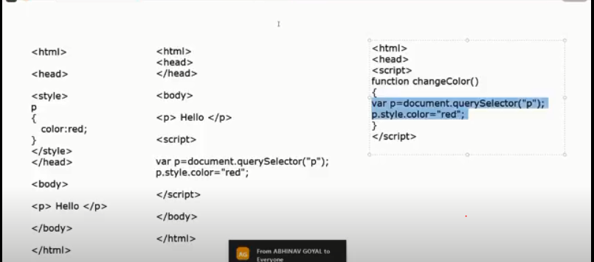

1. Ex3,--Agar code fun ke andar h to tabhi execute hoga jab fun call hoga.
2. Ex2--Liken if direct code likha to vo pehle execute hoga, agar function nhi lga rhe direct likh rhe to body me script tag lgana chaheye.

Example-

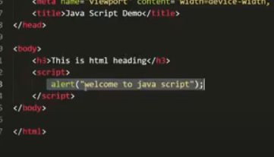

Check in firefox, because in chrome v8 will add h3 in buffer

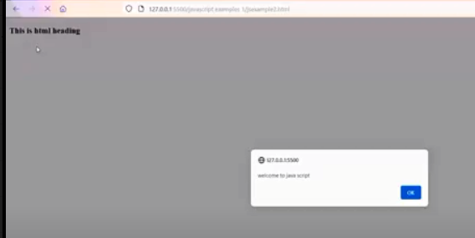

Ex of script tag in head-

|  |  |
| --- | --- |
|  |  |

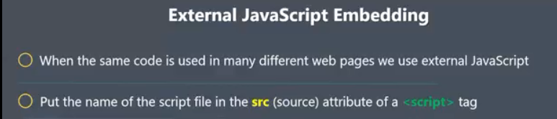

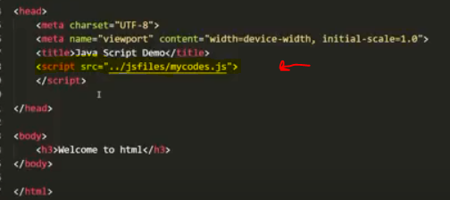

-------------------------------------------------------------------------

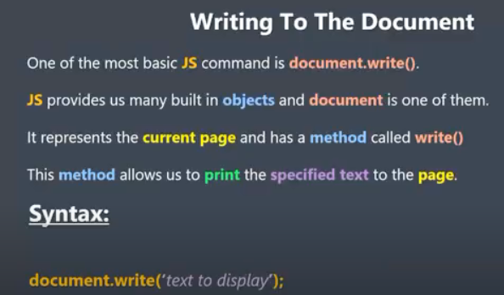

Ex-

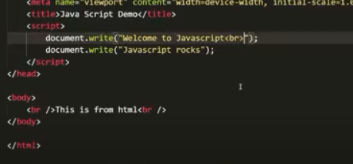

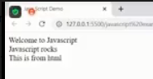

Ex 2

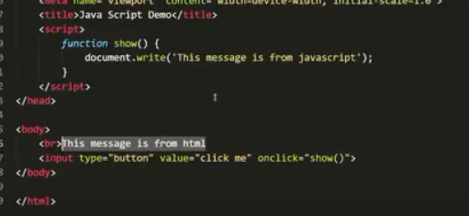

o/p-

|  |  |
| --- | --- |
|  |  |

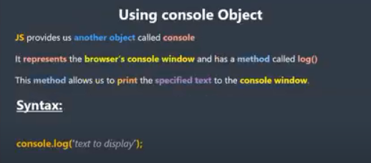

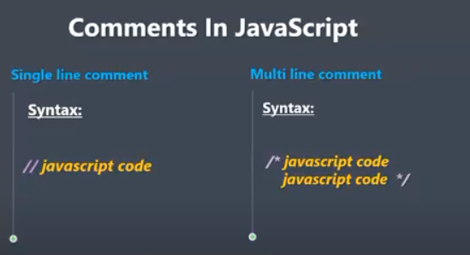

**************************************************************

Chapter-4

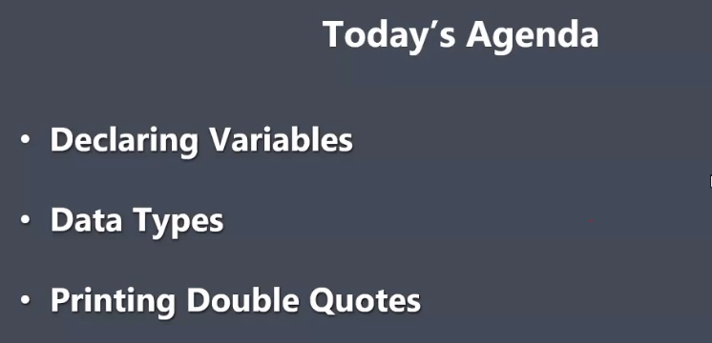

Var , let , const are keyword in js, total 63 keyword are available in js

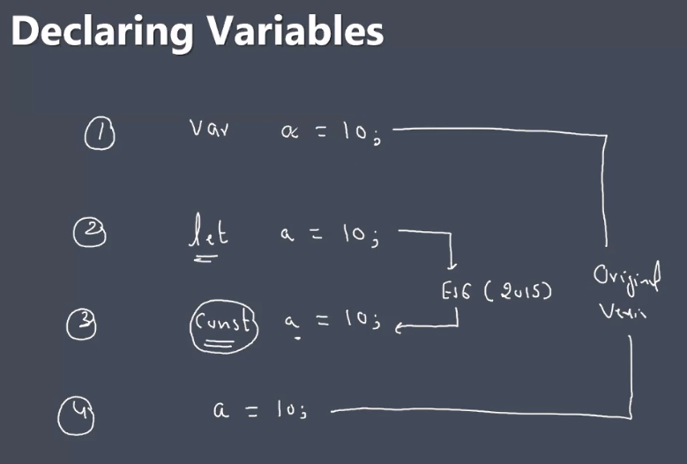

If we are not writing var, let, const, simply

a=10; assignment is compulsory

a; (error – a is not defined)

If we are declaring variable using const then 2 things

1. Initialization is compulsory
2. Value can’t be changes/override

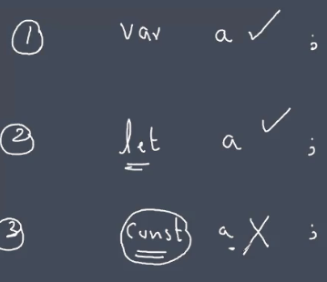

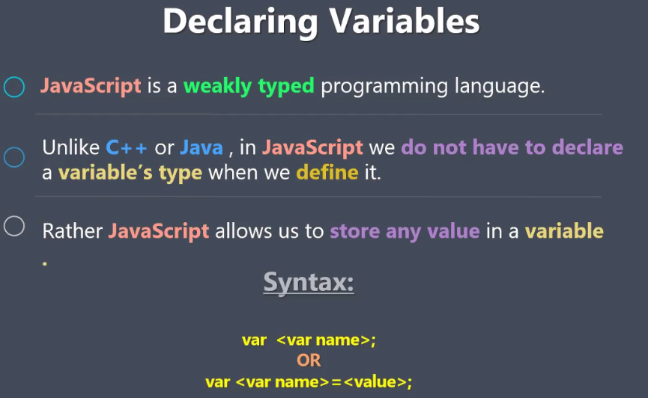

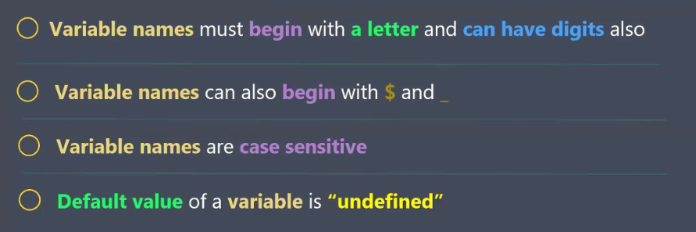

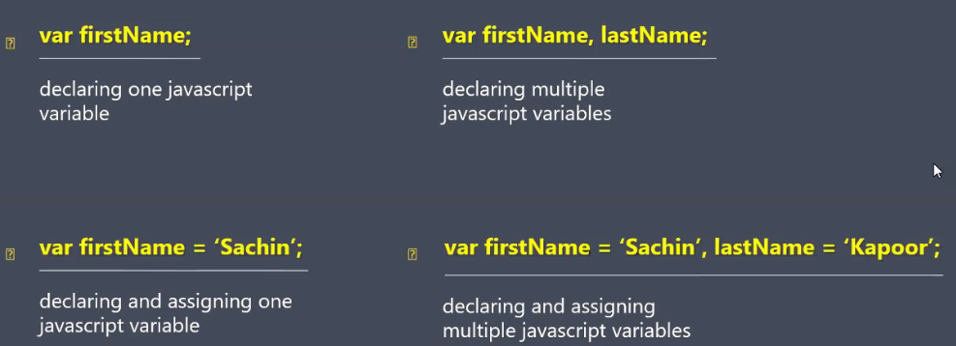

-------------------------------------------------------------------------------

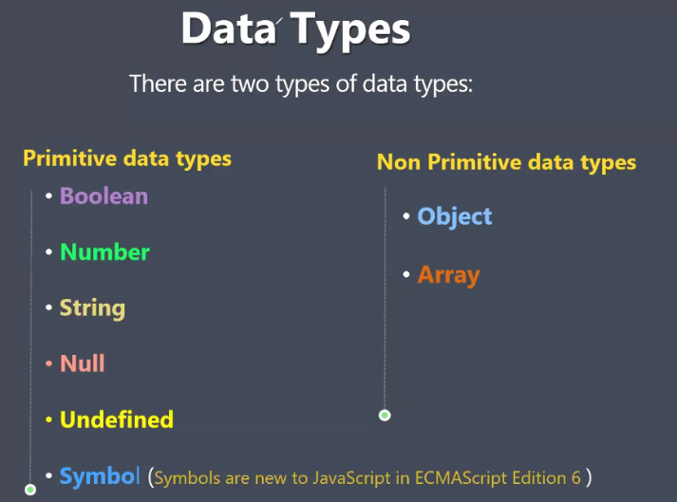

Undefined and null is data type and type both.

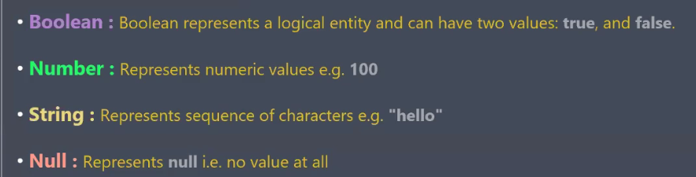

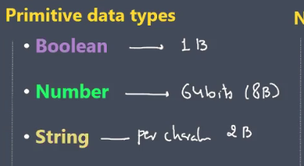

**Undefined AND Null**

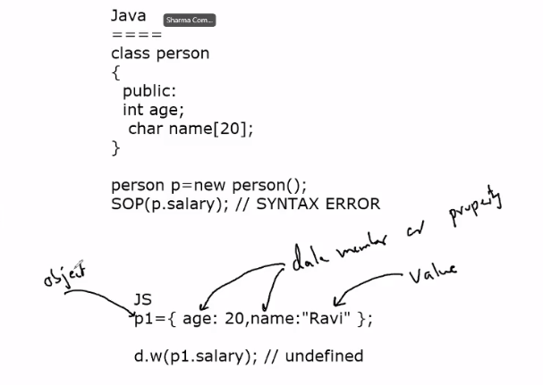

|  |
| --- |
|  |

**Undefined means – variable hi missing h**

**Null means – var h , but value hi missing h**

*********************************************************

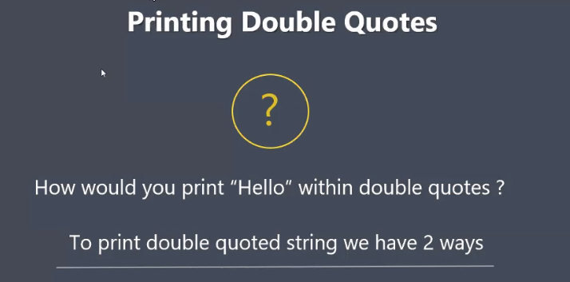

|  |  |
| --- | --- |
|  |  |
|  |  |
|  |  |
|  |  |

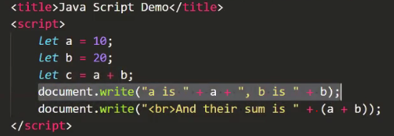

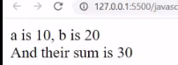

+++++++++++++++++++++++++++++++++++++++++++++++++++++++

**Template Literal**

Backtick will be used in this

|  |  |
| --- | --- |
|  |  |
|  |  |

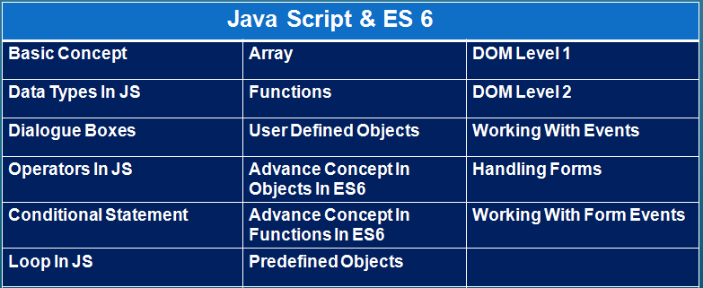

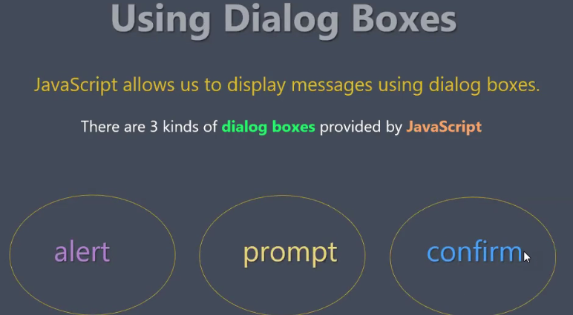

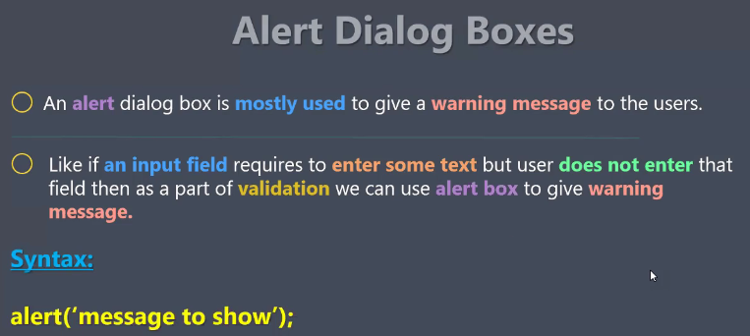

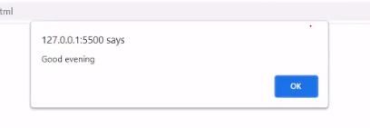

This alert box is default , we can’t change its position or anything .

If we want attractive alert box , we can use libraries

**JavaScript libraries**-

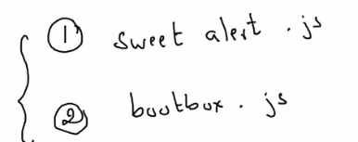

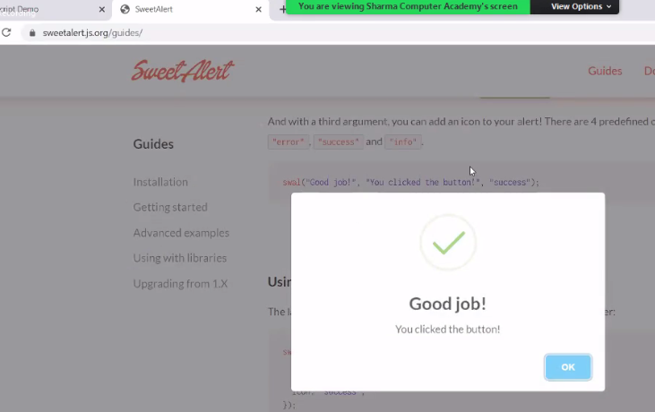

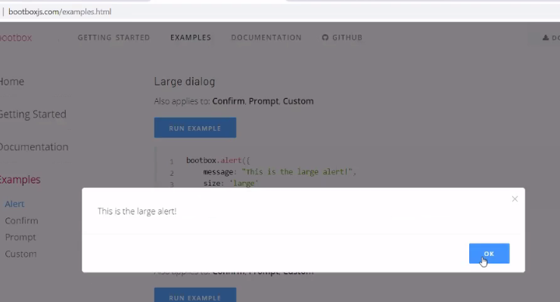

******************************************************

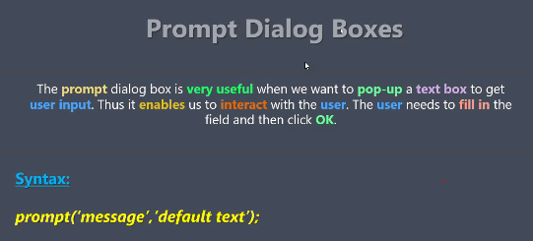

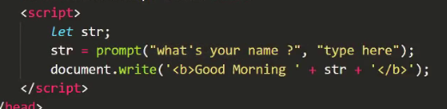

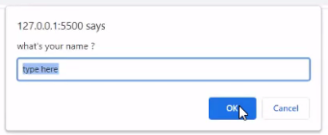

1. If we will not write anything in box—empty string
2. If we press cancel – null return

**Prompt return value in form of string**

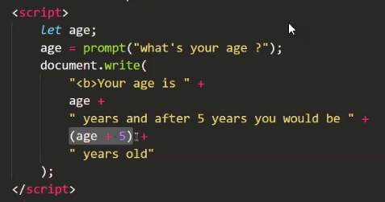

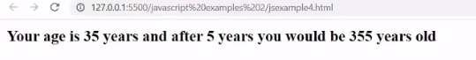

**What to do now?**

**parseInt**

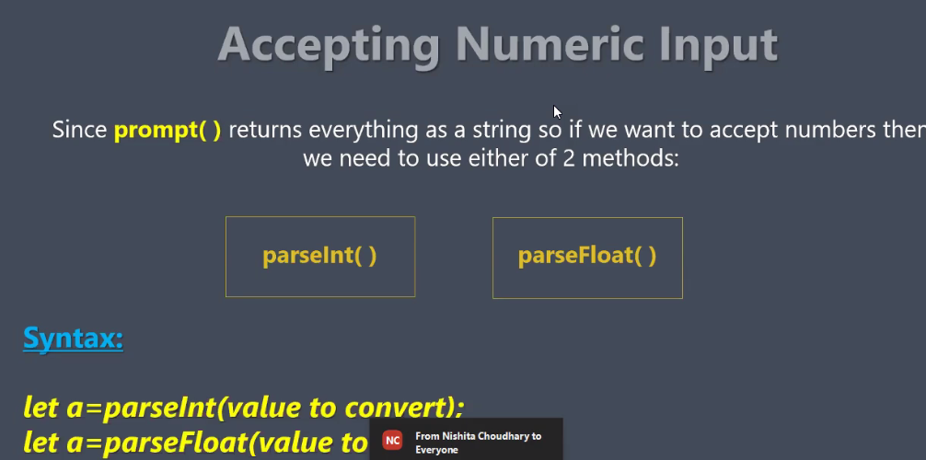

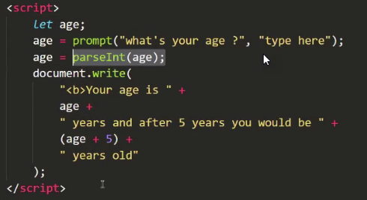

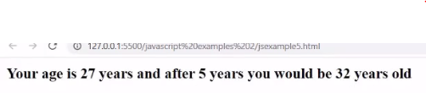

**Note: If we will enter 27.5 , then js will return 27**

**34sachin -----34**

**Sachin34---NAN**

**parseFloat()—**

**27----27**

**27.5---27.5**

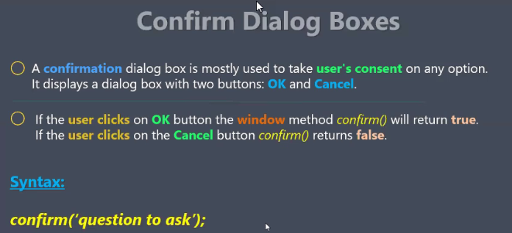

**Window (predefined obj)---------🡪document(obj)**

**----------🡪alert, prompt, confirm (method)**

**Is there any difference in method and function ?**

**Yes. Method ko obj call krta h (.) lga ke.**

**But hmne to direct call kiya alert, prompt.. ko?**

**This are method of window, and window is default obj.**

**window.alert() ===alert()**

**window.document.write() =====document.write()**

**Object in JS-**

1. **Window**
2. **Console**
3. **Document (window ke andar document h)**